
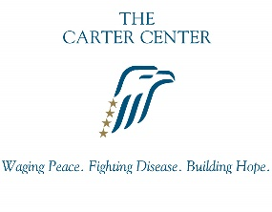


Democracy and Electoral Integrity Completion Fellowship
Guidelines for 2027-2028 Fellowship Year

Application and General Fellowships Recommendation Letter Due:
December 15, 2026 (11:59pm)

The Laney Graduate School, The Carter Center’s Democracy Program, and Emory’s Department of Political Science will support one Democracy and Electoral Integrity completion fellowship for doctoral candidates in the political science PhD program.
The Democracy and Electoral Integrity Fellow will conduct research to support The Carter Center’s Democracy Program and Emory University, collaborating with the Electoral Integrity Project (EIP). The EIP is one of the leading academic data and research initiatives focusing on the democratic quality of elections around the globe and how they can be improved. The EIP is an independent academic project directed by Dr. Holly Ann Garnett and Prof. Toby S. James. It is housed at the Royal Military College of Canada/Queen’s University in Canada and the University of East Anglia in the UK. The Carter Center is a partner of the project. The EIP maintains a cross-national data set of expert perceptions and supports innovative and policy-relevant research comparing elections worldwide. The dataset uses expert perception surveys to provide valid, reliable, and generalizable empirical evidence regarding electoral integrity. It also supports a research community by engaging scholarly and practitioner networks drawn from diverse disciplines, theoretical approaches, global regions, international organizations, and methodological techniques to advance knowledge of electoral integrity.

The fellowship is a completion fellowship, and the fellow is expected to complete their dissertation during the fellowship year. The successful candidate will receive a stipend for 9 months (September - May) along with a 100% subsidy for the Emory University Student Health Insurance Plan (EUSHIP). Insurance coverage lasts through July. The first payment will be distributed at the end of September. The current fellowships stipend rate is $31,500 paid over 9 months.

Responsibilities
The Fellow will work approximately 20 hours per week (below are hour estimates for how to expect to balance your time each week) under the supervision of the of The Carter Center’s Democracy Program Director and Data Scientist, to shape and support the EIP collaboration, including the following responsibilities:
The Carter Center (10-15 hours/week)
- Support and further research related to electoral integrity, election management, international observations, measurement, and other related topics with the guidance of the Democracy Program Director and team
- Provide summaries of current academic research and methods related to elections, electoral integrity, democracy promotion, and related topics
- Leverage existing data (e.g., PEI, VDEM) to provide address and help answer timely, policy-relevant questions
EIP (5-10 hours/week):
- Oversee and check the work of undergraduate assistants regarding election lists and expert lists
- Send survey invitations and reminders
  - Update the EIP team regularly on the progress of survey sending and responses
- Respond to emails and queries about the Perception of Electoral Integrity (PEI) Index and survey
- Assist in cleaning of data for public release
- Assist with ‘Year in Elections’ Report
  - Assist with presentations on the ‘Year in Elections Report’
- Take part in EIP fellowships scheme, including seminars and other opportunities other assignments as directed.
Applicants must meet the eligibility requirements listed below. Applications will be evaluated based on their methodological qualifications, research interests, and the likelihood that the applicant’s research focus will produce mutually beneficial collaborations. The goals of this fellowship include enhancing the applicant’s technological, coordinating, and administrative skills; methodological experience in supporting quantitative and qualitative research on democracy and electoral integrity; and research opportunities related to democracy and elections in transitional states. The ideal applicant will be proactive and comfortable working within a dynamic environment.
Eligibility and Evaluation
Students beyond the fifth year may use the Democracy and Electoral Integrity Fellowship to extend their support. To be considered for the fellowship, applicants must:
- Be a doctoral student in the political science PhD program
- Be a full-time doctoral student in good standing, both in the Laney Graduate School and in their program
- Be in candidacy during the fellowship
- Have evidence of outstanding academic performance

If a prospective applicant has another fellowship or funding source: please confirm in advance before applying that additional funding from the Democracy and Electoral Integrity fellowship is accepted under the terms of that other funding source.
Application Procedure
A complete application must include:
- Statement of purpose to explain interest, including:
  - how this fellowship may enhance the applicant’s future career;
  - a brief description of the dissertation, thesis, and/or research project, including progress thus far;
  - coordinating and organizing experience
- Curriculum vitae
- A general letter of recommendation from an Emory faculty member, preferably the dissertation director or another faculty member who has worked with the applicant and can speak to his or her progress on the dissertation and/or performance on previous graduate assistantships. The letter will be uploaded by your recommender into the LaneyConnect system via an email link you generate through your application.

If this is your first fellowship (non-DTF) application submission in LaneyConnect that requires the LoR: The LaneyConnect system will allow you to select a recommender, and they will receive an email notification of your request. If you already had a general fellowship LoR submitted: the system will populate your application with the previously submitted LoR. Your recommender can only submit the letter once all fellowships in LaneyConnect (only exception is DTF, which has a separate process). This means that your letter writer only needs to write one general letter of support and should not mention any specific fellowship (unless you intend to apply for one fellowship only this year).
Please note that the system will generally take several hours after your submission to send email link to your program administrator. So plan accordingly. All files (including the LoR) must be submitted by the deadline. There will be no exceptions to this policy so ensure that you apply in advance with enough time for the system to generate the email link. We will not accept any applications with missing materials nor accept any materials outside of the system.
- It is the applicant’s responsibility to make sure their recommenders understand the deadline by which they need to submit the LoR once they receive the email link (please make sure they also monitor their spam folder in case their account has a high filtering function).

Person to Submit the General Letter of Recommendation
In the actual application for any applications that require the general LGS Fellowships LoR, the student will see this section:
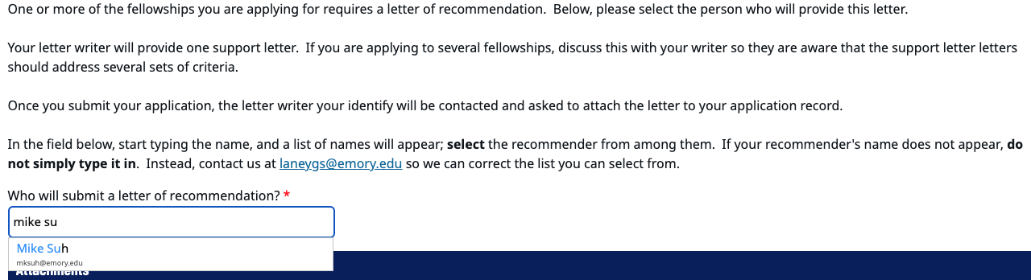

Make sure you start by entering the name (NOT the person’s email) of the person and the system should auto-populate as you begin typing with the person you are looking for. Click the correct person’s name so that the system correctly identifies the person who will receive the link to upload the general fellowships LoR.
Applications that have been submitted cannot be un-submitted. If you selected the wrong person, then it is your responsibility to make sure that person works with the correct person to upload the letter.

Application Submission
All nominations and applications, including supporting materials, will be uploaded using LaneyConnect (new application portal): https://laneyconnect.emory.edu/manage/login?realm=&r=/portal/laney-connect-hub. The portal may not yet be active but when it is activated:
- Select the appropriate fellowship from the list and follow the upload fields. The application will not let you proceed until you upload all the necessary materials. And it will not save incomplete applications so please be sure to have all materials and information ready to upload/complete.
- If you are applying for multiple fellowships, you may select several at one time and submit all materials for the fellowships you intend to apply for (it will not save progress, however, so you must complete your session). Or you may access the portal later and add additional fellowship(s), if eligible, and submit required files for the new fellowship(s) selected (and click “Update” in the online form to complete this process).

In the LaneyConnect application portal, if the applicant has already submitted files that are standard requirements (e.g., transcript), they will not submit it again for a different fellowship. It will pull from the already uploaded file and be included in all fellowship application(s) that require this file. This means that students will submit standard files only once and can focus on documents such as the ‘statement of purpose’ which will be specific for each fellowship that requires this document. If you have questions about using LaneyConnect, please contact us at: LGS.profdev@emory.edu. You will need to upload the application items as PDF files

Award Notification
Applicants will be notified by January-February 2027.

Terms of Fellowship
Fellows who are awarded and accept the fellowship award agree to commit to the course teaching load or the general hours/week and responsibilities as described in the sections above. Fellows who do not uphold the requirements of the fellowship may have the fellowship revoked and may lose their funding and EUSHIP subsidy for the remainder of the fellowship term.
Please note that in cases where there are partner units involved, the fellow is responsible for responding to the fellowship director/coordinator in a timely manner and is expected to fulfill the responsibilities as outlined by the original fellowship call. If the student is unable to communicate and respond in a timely manner or is unable to fulfill those responsibilities, their stipend (and EUSHIP subsidy) may be withheld or the fellowship slot may be removed. In some fellowships, the fellow is expected to begin their role around mid/late-August.
When applicable, this fellowship award replaces other graduate school stipend and scholarship funding* a student may have been scheduled to receive for the fellowship year, and the eligibility for that funding cannot be reserved to be used in a subsequent year.
*This does not apply to smaller awards such as WiNS, Centennial, or ARCS Foundation awards.

All LGS fellows will be required to submit an intake form and an outgoing form as part of this fellowship.
- The first intake form will involve the award letter and student details.
- The second intake form will be provided in Spring of the fellowship year.

Fellows who receive offers for other awards must contact the Laney Graduate School PDCP Office (LGS.profdev@emory.edu) to determine whether the two awards may be held concurrently. Please include with this email full details about the other award you may be inquiring about.
In general, external fellowship awards may not be held concurrently with LGS completion/advanced fellowship awards.

Please note: Unless indicated otherwise, all LGS fellowships require on-site in-person participation and completion. There are no remote options available unless explicitly indicated.

Questions about the Electoral Integrity fellowship?
For questions about this specific fellowship, contact Tony DeMattee: anthony.demattee@cartercenter.org.

Questions about the LGS fellowships application system?
For general questions about LaneyConnect, contact LGS.profdev@emory.edu.

